# Instructions

Every should get into groups of 4 or 5 people maximum

Every group has to have a leader.

The leader has one advantage:

* He can ask as many questions as he wants

The leader has three responsibilities

* Explain things to his team
* Answer the questions to his team mate
* When he can't answer the question of his teammate, he has to ask the teacher

**Anyone who is not a team leader cannot ask questions.**

Team leaders do more work, but they learn much much more. If you want a career in software development, I suggest you be a leader.

If you want to ask a lot of questions, you should be a team leader.

# Exercise 1

Every member of the group has to find a file that's been edited by at least 8 people. The following steps explain how.

Go on github.

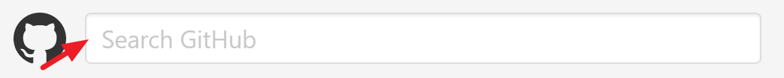

Enter a search. It could be anything. For example, we can search for the word training

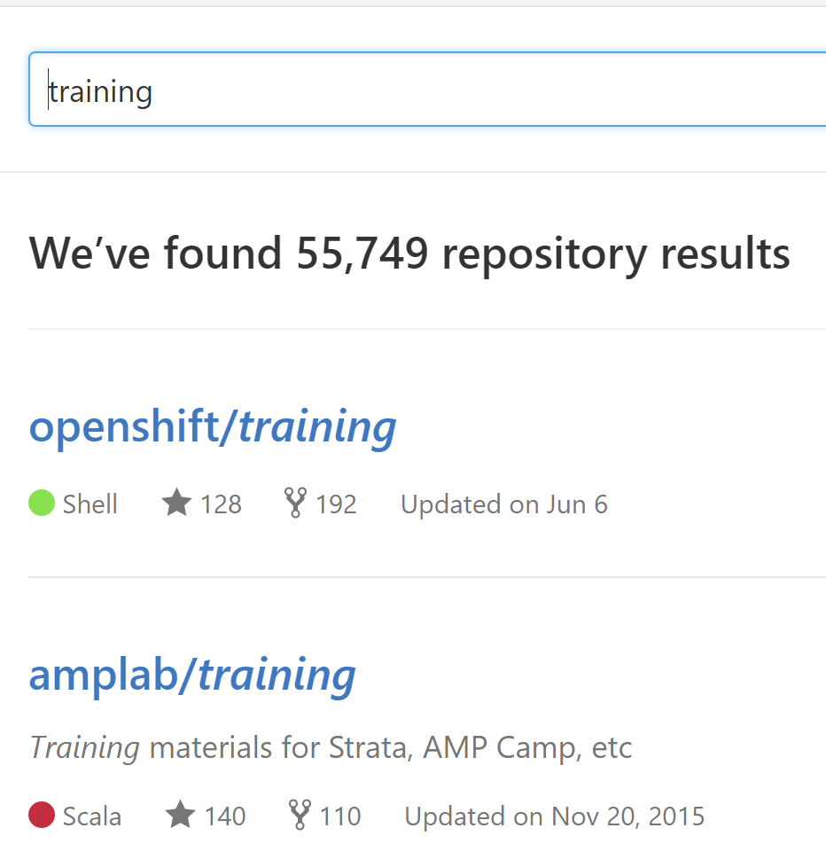

Let's say we pick the first one

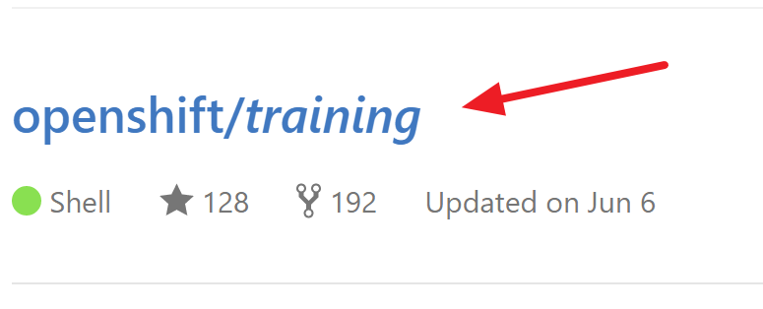

And we pick a file in that repository

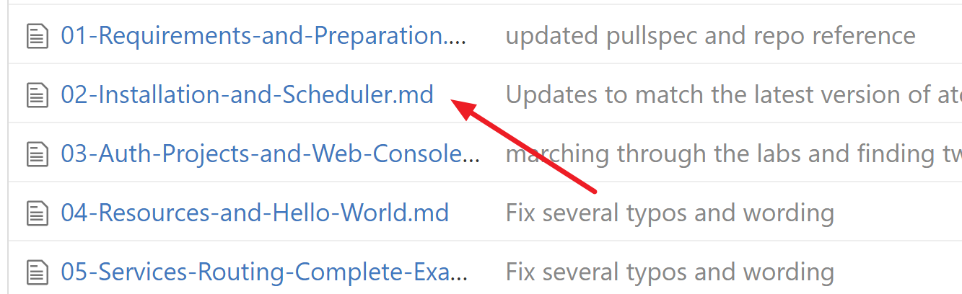

Then we can see who edited that file

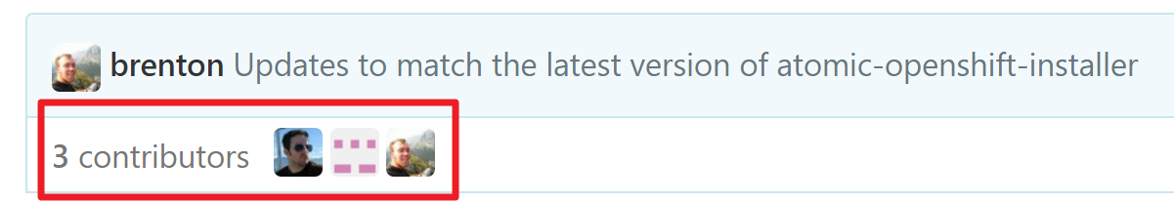

And you can see their names if you hover your mouse over their picture

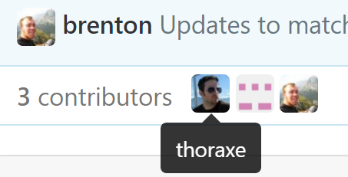

Every member of the group has to find a different file that's been edited by at least 8 people. Try different searches on github.

# Exercise 2

Log into github



Create a new github repository

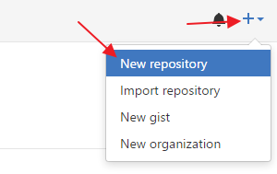

Find your project's web URL

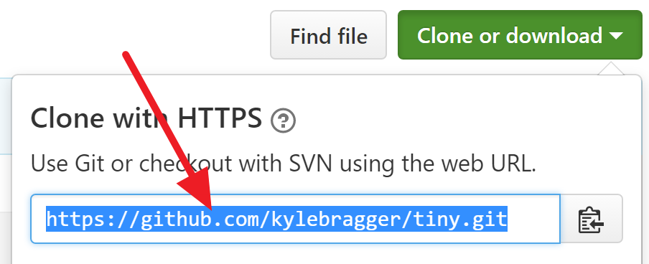

Clone your repository using the the web URL

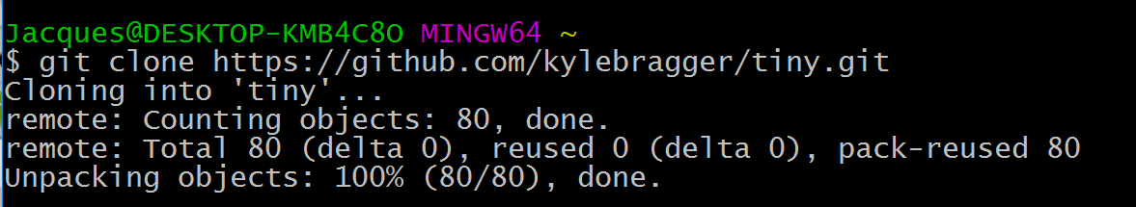

The following picture gives you a hint on how to do it.

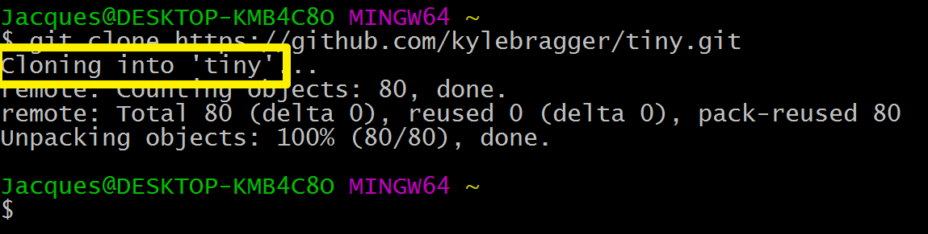

Change to that directory. In the following picture, replace 'tiny' with your own repository name.

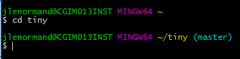

From the git bash, change the directory like this:

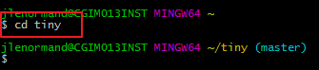

In your git bash, type pwd to get the location of your repository.



Open the file explorer

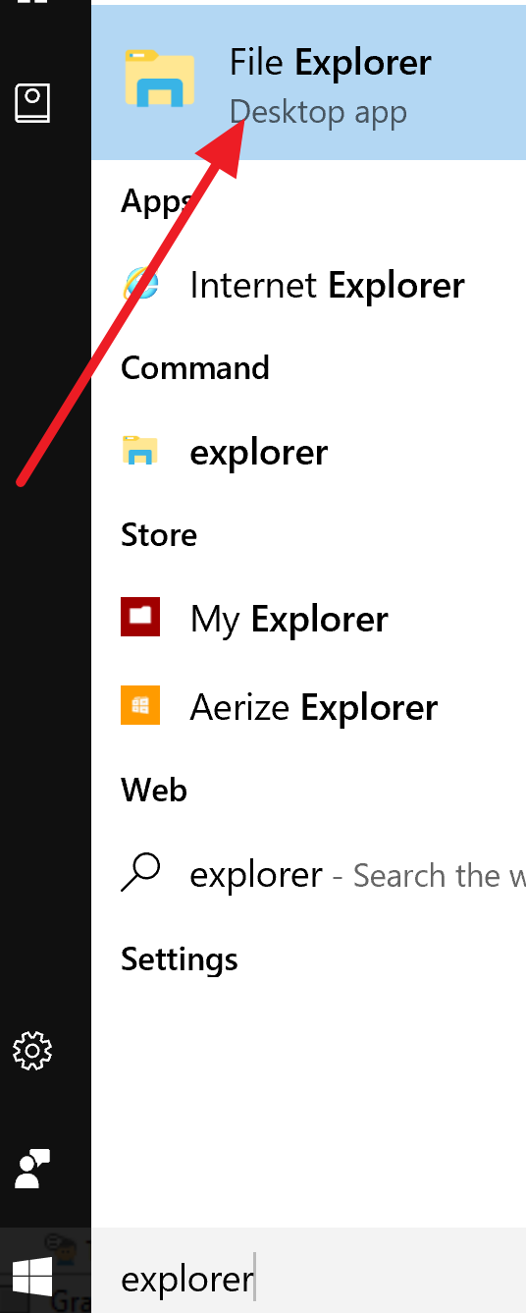

Use file explorer to go to your repository directory. Add a file to that directory.

From the git bash, use these commands create a new commit and push it to github:

git add .

git commit -m 'some message'

git push origin master

Then add another file to that directory.

Push **the new** changes to the directory by using the same commands

git add .

git commit -m 'some message'

git push origin master

Open github and look at all your previous commits. You should see at least 2 commits.

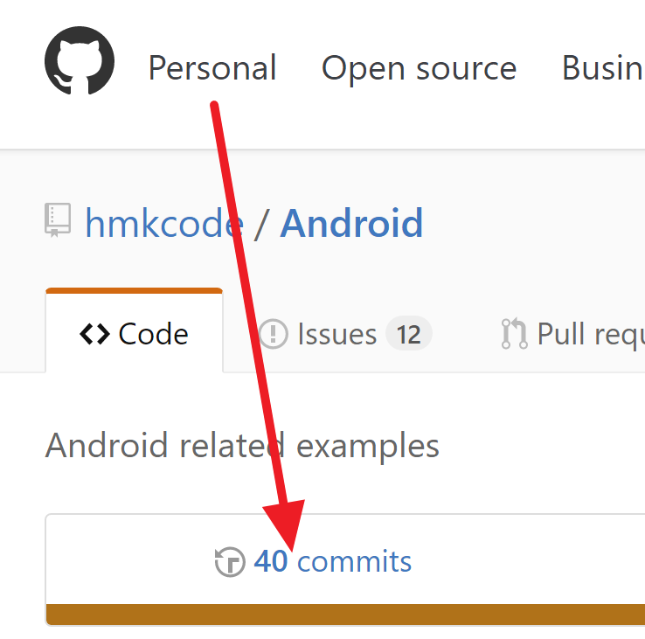

# 

# Exercise 3: group exercise

The team leader creates a git repository

That person shares his repository with everyone else. The next image shows how to do it.

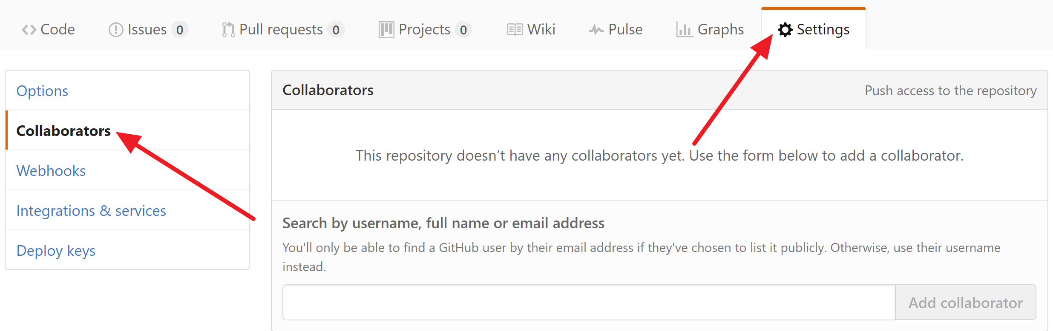

Every person in your group clones that repository

Every person in your group makes changes to the local repository and pushes the changes to github

If you go on github.com and you check your repository, you should see at least 4 files (one for each person in your group)

The team leader must send a link to your github repository to your teacher using slack. The link is in the address bar



# Exercise 4: group exercise

The team leader creates a git repository

That person shares his repository with everyone else. The next image shows how to do it.



Every person in your group clones that repository

One person in the group creates a file called A.txt in their local repository and pushes it to github

The next person does the same with file B.txt

The next person does the same with C.txt

The next person does the same with D.txt

etc...

If you have 4 people in your group, there should be 4 files in your github repository.

Please check that the number of people in your group matches the number of files in your github repository.

Every member in the group must now pull the changes from github using this command:

git pull

In this way every member has pulled the changes of all the group members onto their local computer.

They can then edit the files and push them back to github.

**The goal of this exercise: If there are 4 members in your group, there should be at least 4 files in your github repository with 4 contributors**

Send a link to your github repository to your teacher through slack. The link is in your address bar.

